# Chapter 3

# Methodology

## 3.1 System Design Methodology

**Agile**

Agile resulted as a “solution” to the shortcomings of the waterfall methodology. It follows an incremental approach, Instead of the sequential design process. While choosing the methodology we considered the following factors why agile was suitable the system.

* In Agile rapid production is more important than the quality of the product, this suits well to the enterprise environment where functionalities can be tested before without regard to the quality and production is done with a quick pace.
* Clients are able to change the scope of the project, this is because the system is meant for use by enterprises who have different needs and working environments, this proves changing the scope will be inevitable.
* It is suitable when there is no clear picture of what the final product should look like, In our project the final product is still unprecedented, can only be actualized in the final stages.
* Since agile is best suited for products intended for an industry with rapidly changing standards, explains the reason why we chose it, because most of the industries have dynamic needs and goal, so the system should be flexible to adjust to the new needs

The twitter sentiment Analysis system uses an agile methodology for the development process. According to ken Schwaber (Schwaber K, 2003) one of the initiators of the agile scrum method, agile is a process for managing complex projects. He puts emphasis on the fact that the methodology is not just limited to software development, but given the tendency for software development processes to be very complex, agile is well suited for the managing them (Brooks, 1978).

## 3.1.1 Overview

The scrum method is incremental, with each increment called a sprint, each sprint is recommended to last for 4 weeks. Before the sprint there is a planning meeting for each sprint, where a customer decides which features should be implemented in the upcoming sprint. During the sprints the teams meets on a daily basis on short meetings called scrum. A sprint review meeting is held at the end of each sprint, and the customer is able to see the existing accomplishments for the preceding sprint. Teams can also hold sprint retrospective meetings to, where they can look at the process and then try to find out what went right and what can be improved. The figure bellow shows the flow of the methods.

Figure 2: Overview of the scrum method

Figure 2: Overview of the scrum method

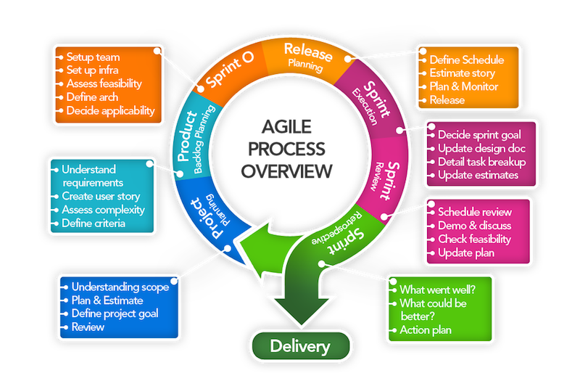

Figure 1 overview of scrum method

## 3.2 Scrum Artifacts

Scrum being an agile method, follows that the formality of the project is as low as possible, it thus facilitated necessary changes to be made to the project. The customer is also able to see the project progress since this improves their motivation and involvement. Artifacts of scrum includes:

1. The product backlog
2. The sprint backlog
3. The sprint burndown chart.
4. The impediment lists

3.2.1 The Product Backlog.

It can be considered equivalent to the requirement specifications, but it has one big difference in that it does not entail long description of each requirement, it has only single sentence description for each requirement. Being a list of such single sentence requirements, it is thus the customer’s priority to keep it prioritized and updated. The customer can add requirements to the list and the team is then responsible for providing estimates of how long the implementation might take.

3.2.2 The Sprint Backlog

It is a list of tasks maintained and compiled by the team based on he the items in the product backlog, initially selected to be part of the sprint. The list is similar to the product backlog, but with a big difference. The items on the product backlog are features requested by the user, the sprint backlog is a list of tasks the developers must do to implement the items that the customer chose from the product backlog. The customer doesn’t need to know about the items on the sprint backlog.

A general rule of thumb is that the tasks on the sprint backlog should always be relatively short, that is between one hour and two days.

3.2.3 The Sprint Burn down Chart

This measures the progress of the sprint instead of the project. It is important because it helps the team discover tasks they did not consider but that must be added to the sprint backlog. Since the chart displays the amount of work remaining and not the amount of work completed, the graph can in fact increase from one day to the next.

3.2.4 Impediment list.

An impediment is anything holding back development in some way or another. It is the scrum master’s responsibility to deal with any such impediments. The list is simply a set of tasks that the scrum master uses to track the impediments that needs to be solved.

3.4 The Sprint Planning Meeting.

In the first session, the Customer chooses high priority items from the product backlog that should be completed in the upcoming Sprint. The customer explains the items to the team and they give an estimate on how long it will take to complete it. The sprint backlog is filled so that the sum of the item estimates is about the same as the available work time of the team during the upcoming sprint.

3.5 The Daily Activities.

During the sprint, the developers work on the items in the sprint backlog. Every day the developers synchronize their progress in a daily Scrum meeting that should last no longer than 15 minutes. During the meeting, all the developers will tell the others what they did since the last Scrum, if there are any impediments obstructing their work and what they are planning on doing until the next Scrum. Another important day to day activity is updating the sprint backlog and burndown chart.

3.6 Sprint Review Meeting

At the end of the sprint, the team meets with the customer and presents the result of the sprint. The users demonstrate the functionality they have completed and gets feedback from the customer. If the demonstrated functionality is what the customer wanted, then this gives the team a feeling of accomplishment as well as the customer a proof that the project is moving in the right direction. If the demonstrated functionality isn’t quite what the customer was looking for it is now easy to explain how it is different and what should be done next. In some cases, it is enough to make a few changes while in other cases the implemented functionality must be discarded.

## 3.6. Sprint Retrospect Meeting

The intention of this meeting is to help the team improve their development process. The meeting is attended by the team, the scrum master and the customer (optional). During the meeting the team members take turns saying what went well during the last sprint, and what could be improved. After all team members have had their say, they prioritize the possible improvements and discuss them in order. The meeting should not last more than 3 hours.

## 3.7 Project Startup

Ken Schwaber has had much success with his kick-starting of Scrum projects as described in the book Agile Project Management with Scrum (Schwaber, 2002). This process goes as follows.

The Scrum Master works with the customer and prepares a backlog. Then the Scrum Master, the Customer and the Team uses one day to go over this backlog. During this first day the customer explains the items in the backlog to the team, and the team estimates how much work it would take to implement this. The customer then prioritizes the items in the backlog and divides the backlog items into sprints. The following day is the first day of the first sprint. This first sprint isn’t very different from the following sprints, except that the first part of the sprint planning meeting has already been completed.